mkdir -p ~/data/config

mongod \
--configsvr \
--replSet configReplSet \
--dbpath ~/data/config \
--port 27019

mongosh --port 27019

rs.initiate({
_id: "configReplSet",
configsvr: true,
members: [
{
_id: 0,
host: "localhost:27019"
}
]
})
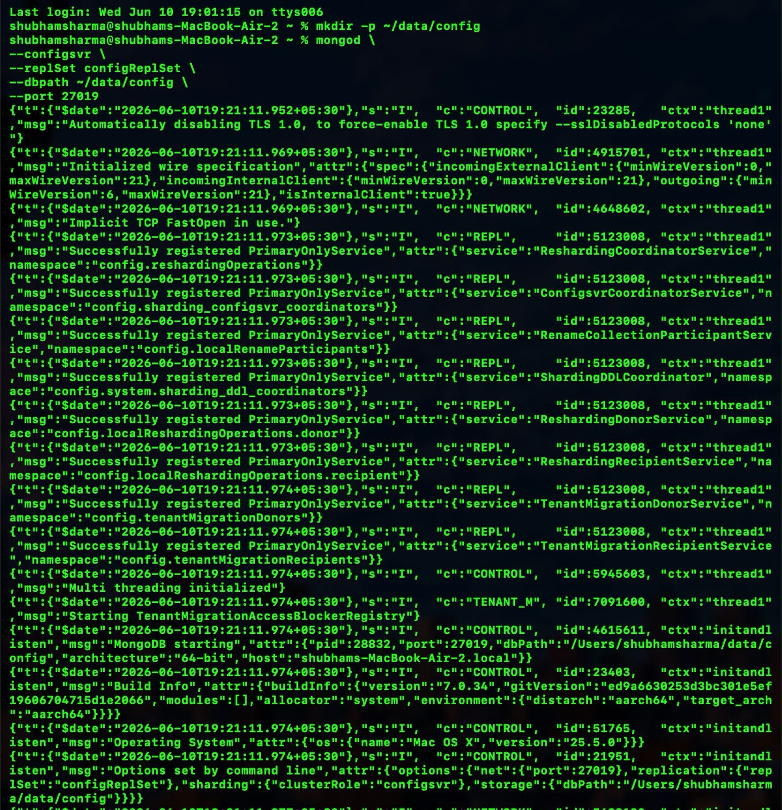
mkdir -p ~/data/shard1
mkdir -p ~/data/shard1
mkdir -p ~/data/shard1.

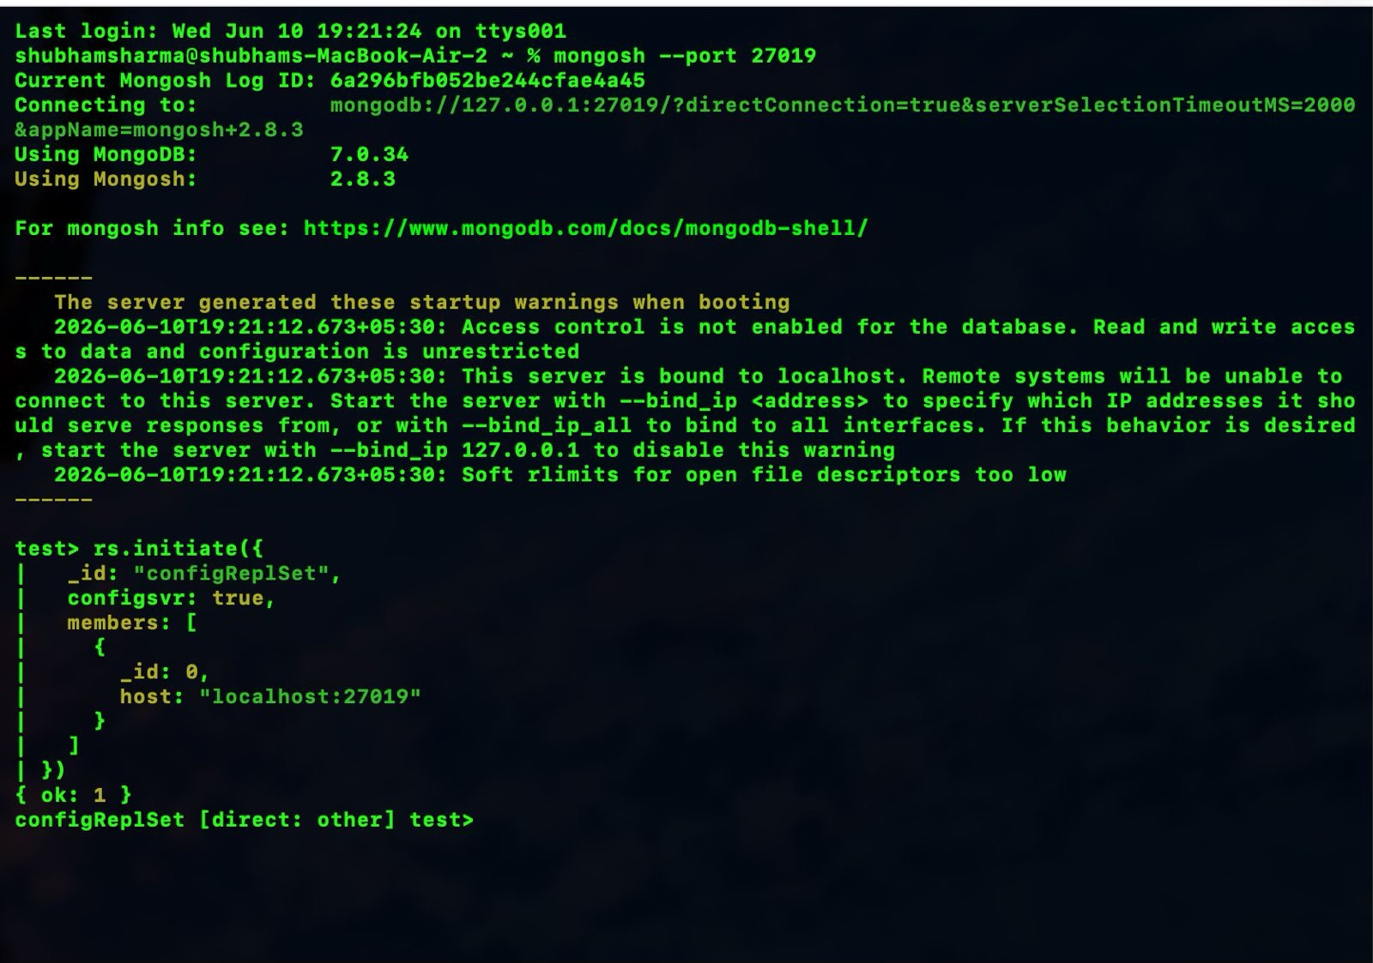
mkdir -p ~/data/shard1
mongod \
--shardsvr \
--replSet shard1ReplSet \
--dbpath ~/data/shard1 \
--port 27011
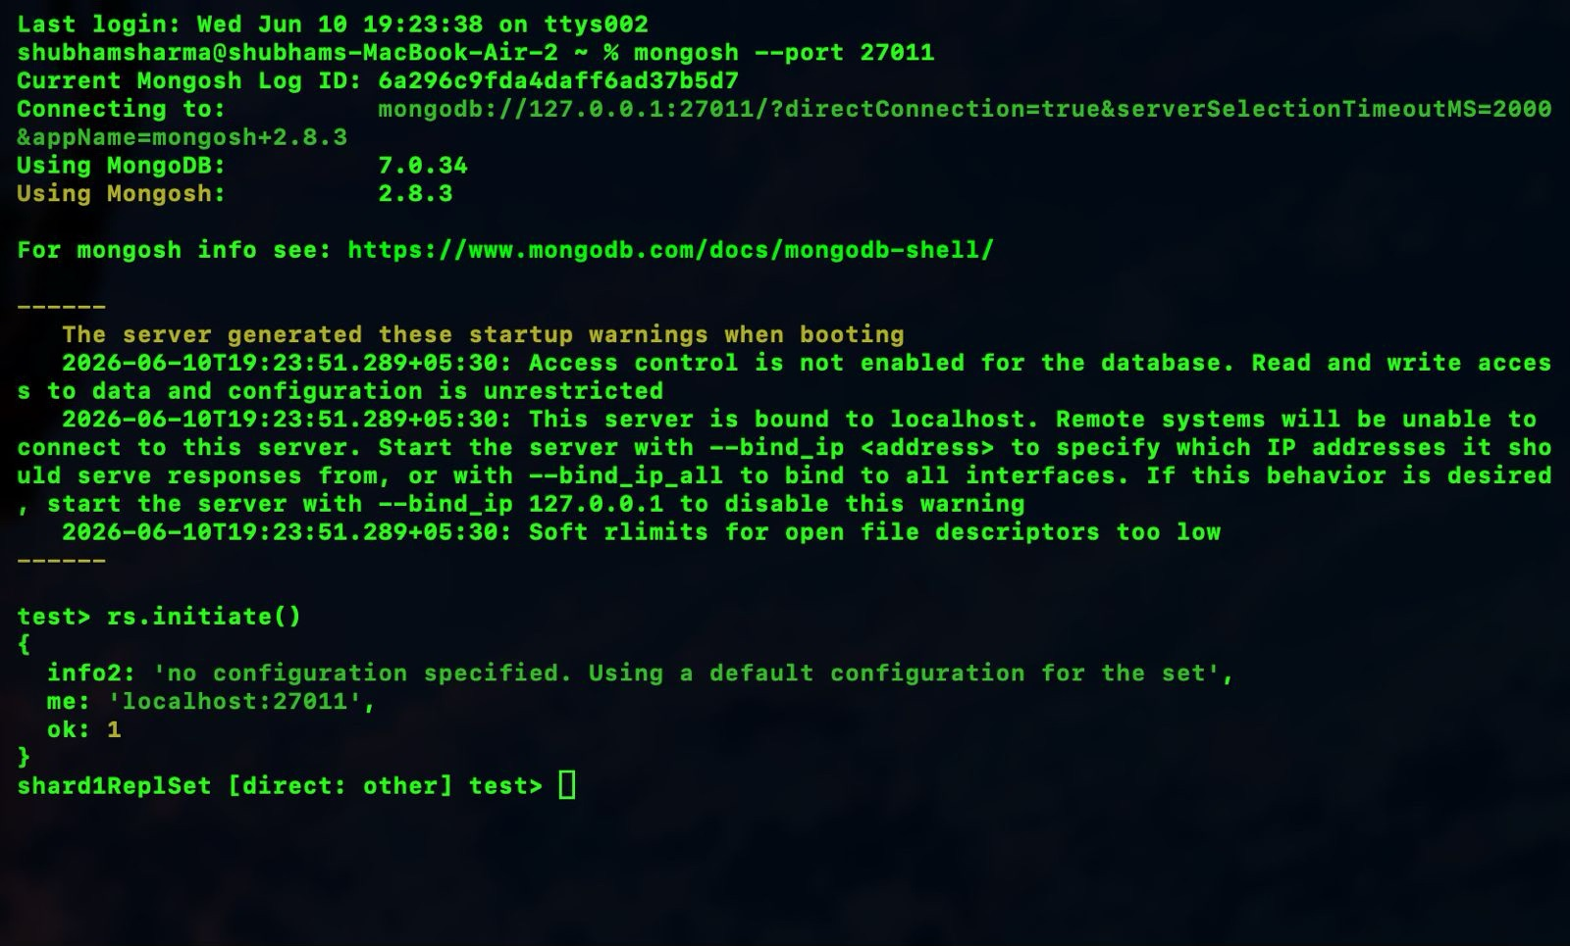

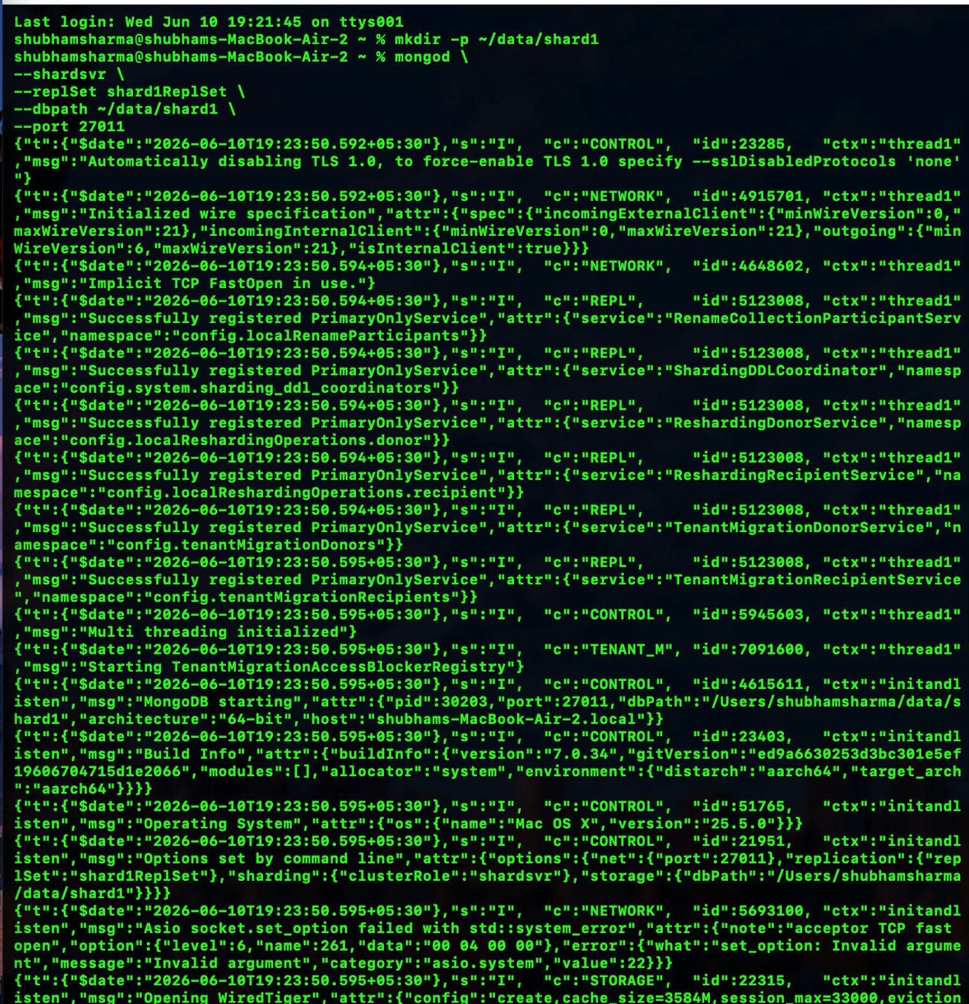
mongosh --port 27011

rs.initiate()

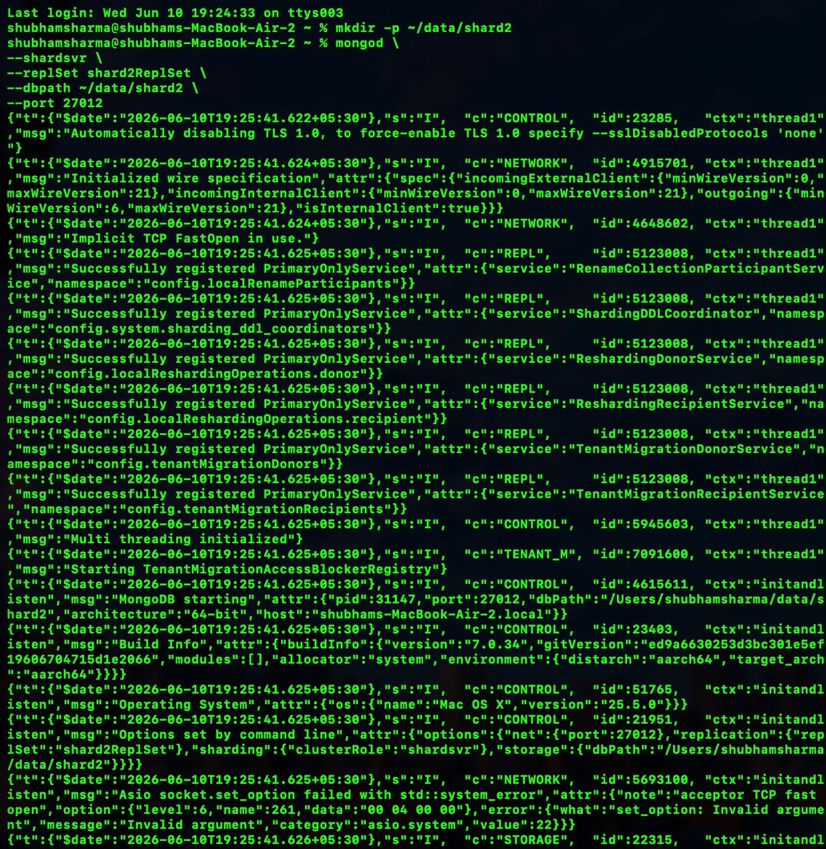

mkdir -p ~/data/shard2

mongod \
--shardsvr \
--replSet shard2ReplSet \
--dbpath ~/data/shard2 \

--port 27012

sh.addShard(
"shard1ReplSet/localhost:27011"
)

sh.addShard(
"shard2ReplSet/localhost:27012"
)

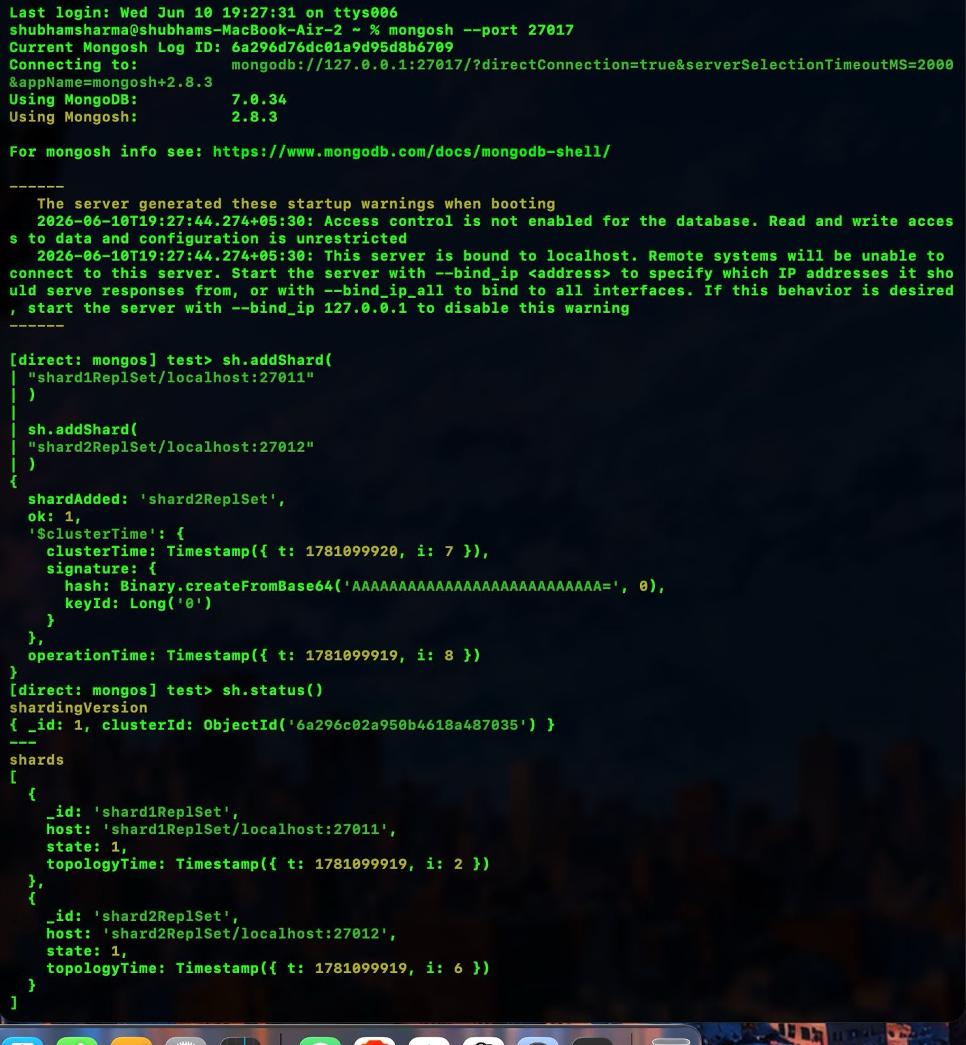
sh.status()
sh.enableSharding(“eCommerceDB")
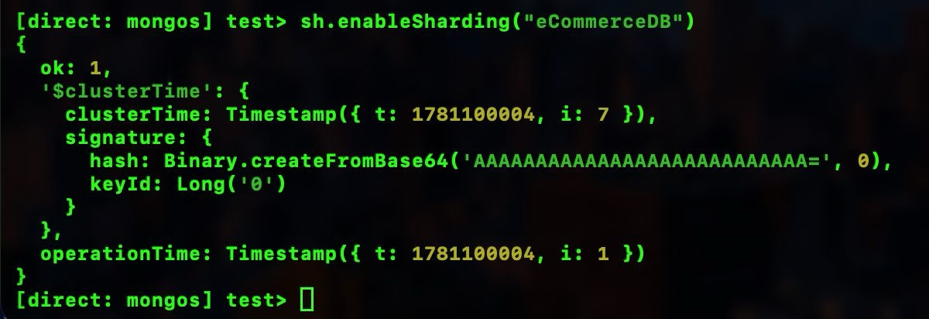
mongosh --port 27011
use eCommerceDB
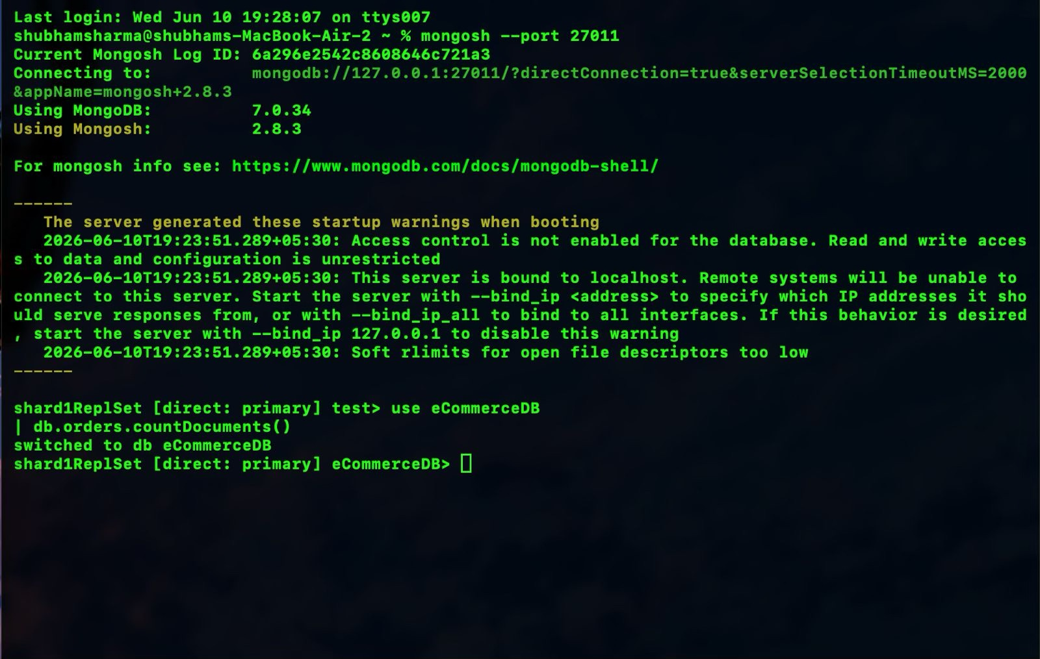
db.orders.countDocuments()

